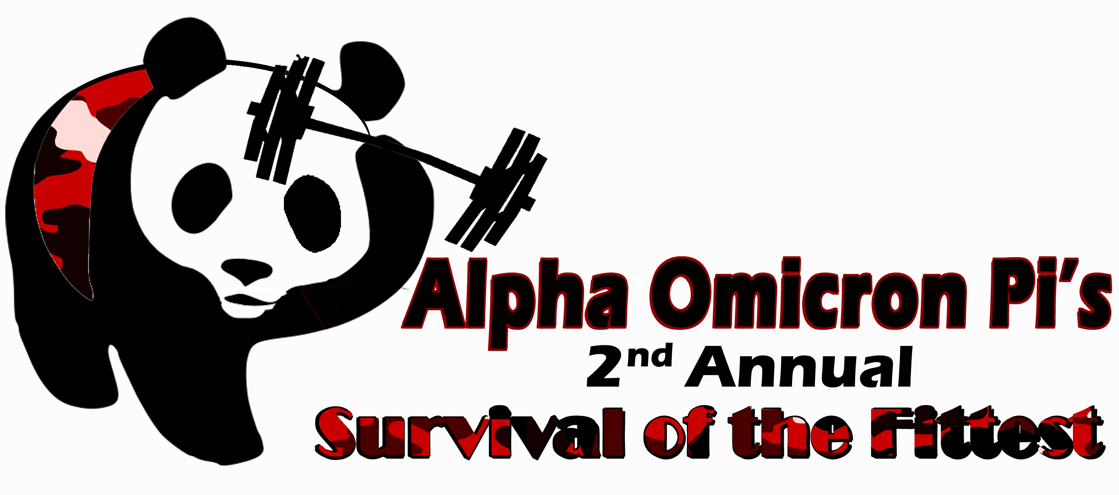
Contact: Michelle Scali
Philanthropy Chair, Beta Upsilon Chapter
Alpha Omicron Pi Women’s Fraternity
Bryant University
(978)-987-8275
mscali@bryant.edu

The sisters of the Beta Upsilon Chapter of Alpha Omicron Pi at Bryant University are showing their gratitude and support to soldiers stationed overseas.
We are asking local organizations and friends of AOII for donations, either monetary or goods, to contribute to care packages that we will be sending to those serving our country abroad. Please see the attached list for suggestions. If you would like to contribute a monetary donation, please make all checks out to Soldier’s Angel’s. All checks will be sent directly to Soldier’s Angel’s Headquarters in North Carolina. When they receive your donation, you will get a receipt from the organization for tax deduction purposes. If you would like to learn more about our efforts, please contact Michelle Scali at (978) 987-8275.
Additionally, we are raising money by creating a competition called “Survival of the Fittest” from Thursday, October 3rd - Saturday, October 5th for students at Bryant University. Each participating student pays an entrance fee and teams compete in various events from racing in a pair of heels to a full-out obstacle course in order to compete for prizes (which we hope will be donated).
Alpha Omicron Pi is committed to not only striving to exceed the expectation within our women’s fraternity, but also when we turn our attention to the world around us. One of the founding principles of AOII is to be of service to others - to bring into the world around us a spirit of love, as an opportunity to give something back to the communities where we are citizens. Our sisterhood is a gift, and we share our gift of friendship through philanthropic events and community service.
Thank you for your support,
The Sisters of Alpha Omicron Pi, Beta Upsilon Chapter
SUGGESTED ITEMS FOR CARE PACKAGES
- Reading material:
  - Magazines
  - Books
  - Cross word puzzles
- Food:
  - Small drink mix packets
  - Candy that will not melt
  - Trail mix
- Clothing:
  - T-shirts
  - Pajama Pants
  - Gym Shorts
  - Any college-themed t-shirts (Soldiers enjoy having something “not military” to put on during down time.)
- Games:
  - Any type of board game (Checkers, Chess, Monopoly etc.)
  - Golf balls and tees
  - Frisbees, footballs, soccer balls
  - Decks of cards
  - Used movies and games
  - Anything remote controlled...planes, helicopters, cars etc. It doesn't have to be anything big and fancy (these can be found at a low cost at Walgreens, CVS, etc).
  - Water balloons, sling shots
- Miscellaneous Items:
  - Random calendars (2013 or 2014 calendars of sports, cars, etc.)
  - Air fresheners for rooms and trucks

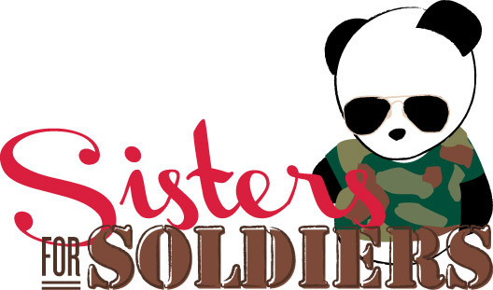
Contact: Michelle Scali
Philanthropy Chair, Beta Upsilon Chapter
Alpha Omicron Pi Women’s Fraternity
Bryant University
(978)-987-8275
mscali@bryant.edu

Thank you so much for deciding to support Alpha Omicron Pi and Solder’s Angels through the “Sisters for Soldiers” program!

Please fill out the following form:
Name (or organization): _______________________________________________
Contact person: _____________________________________________________
Address: ___________________________________________________________
___________________________________________________________________
Phone Number: ____________________________
Donation (please write amount donated or list materials given): _______________________________________________________________________________________________________________________________________________________________________________________________________________________________________________________________

If sending a check, please enclose this form in the envelope with the check (made out to Soldier’s Angel’s) and mail to: Michelle Scali, 1150 Douglas Pike, Box 2330, Smithfield, RI 02917. Please contact Michelle Scali at (978)-987-8275 to have other material donations picked up.

Thank you so much for your support. Please cut along the line for your receipt.

Receipt of Donation to the “Sisters for Soldiers” partnership (Alpha Omicron Pi Women’s Fraternity and Soldier’s Angels) (not for tax use – receipt will come directly from Soldier’s Angel’s):

Soldier’s Angels: A volunteer-led 501(c)(3) non-profit organizations that provides aid and comfort to the men and women serving the United States Army, Marines, Navy, Air Force, Coast Guard, veterans and their families

Donation: __________________________________________________________________________ ___________________________________________________________________________________
Date: _______________

